**PRACTICAL – 4**

**A] Making a Map**

➢ Create a new Thematic Map or open and existing one

➢ Consider the following map as an example map

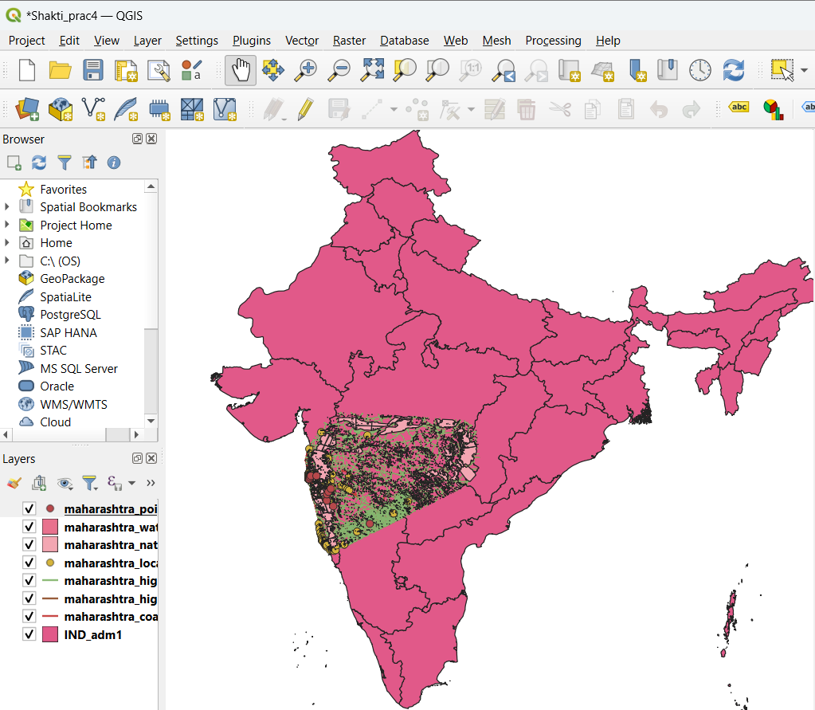

**Steps:**

1) Layer → Add vector Layers → Source (Add 7 Layers from Files)

2) Change properties of Layers (giving labels and Symbology)

3)Zoom the area of Map which you want to create (for eg: zoom at Mumbai)

4)Projects → New Print Layout → Give Name to it → A window will open

5)Add Items → Add Map → click on window → press OK (area of map will appear which you have zoom before)

6)Add Items → Add Picture → click anywhere → its item Properties → Add raster image from file

7)Add Items → Add Label → Name it

8)Add Items → Add Legends →click on window

9)Layout → export as Image → Save it (Map as been Created)

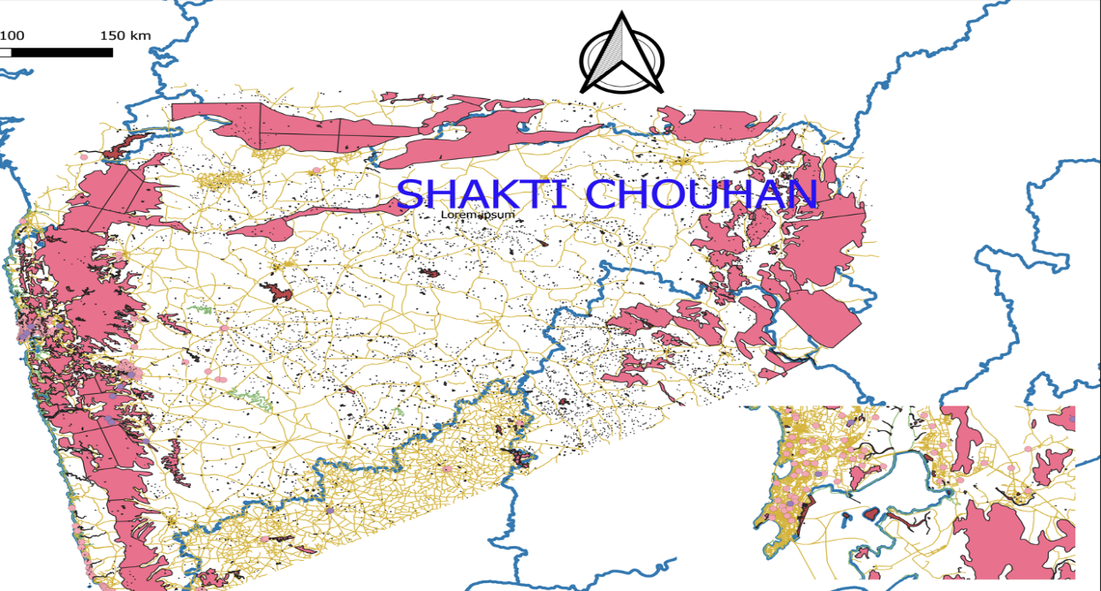Output:

**B] Importing Spreadsheets or CSV files:**

➢ Many times the GIS data comes in a table or an Excel spreadsheet or a list last/long coordinates,therefore it has to be imported in a GIS project.

➢ Sample file for Earthquake data will be used in this practical.

➢ Go to Layer → Add Layer → Add Delimited text Layer

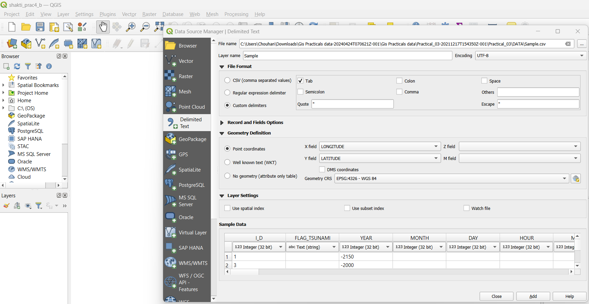

➢ Press ADD and close the window.

➢ Output:

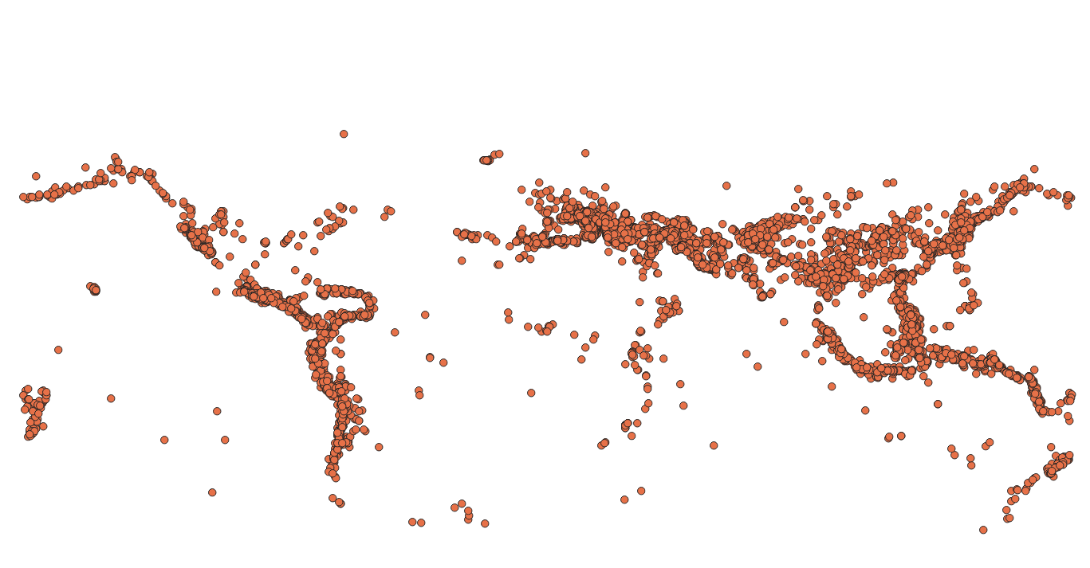

**C] Using Plugins:**

➢ Core plugins are already part of the standard QGIS installation. To use these, just enable them.

➢ Open QGIS. Click on Plugins → Manage and Install Plugins....

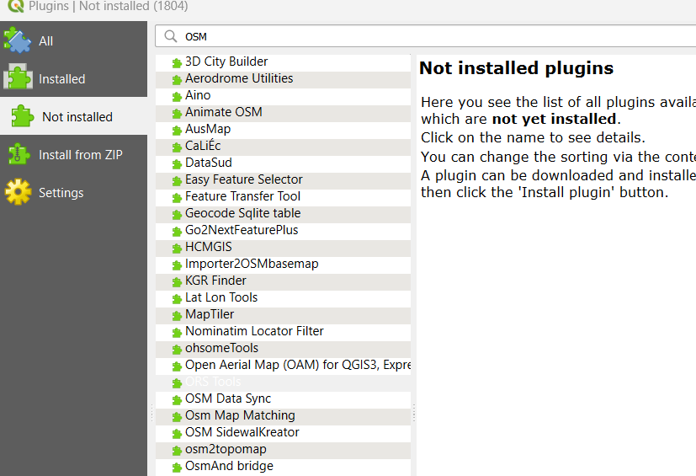

➢ To enable a plugin, check on the checkbox next to Plugin. This will enable the plugin to use it.

➢ External plugins are available in the QGIS Plugins Repository and need to be installed by the users before using them.

**D] Searching and Downloading OpenStreetMap Data:**

➢ We have to install Open Layer and OSM Search Plugin → Not Install → Search for both plugins and install it

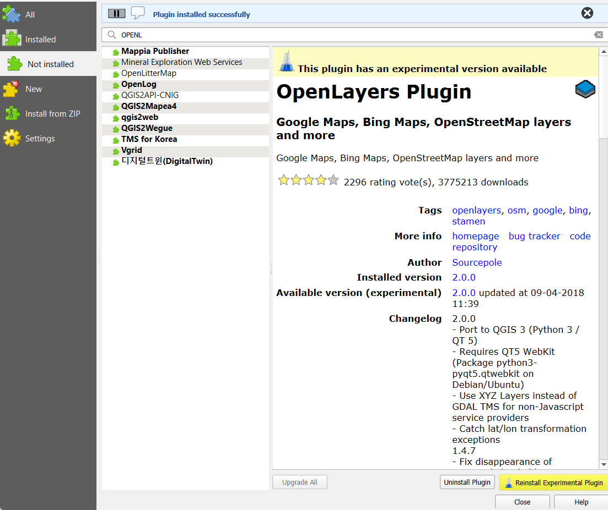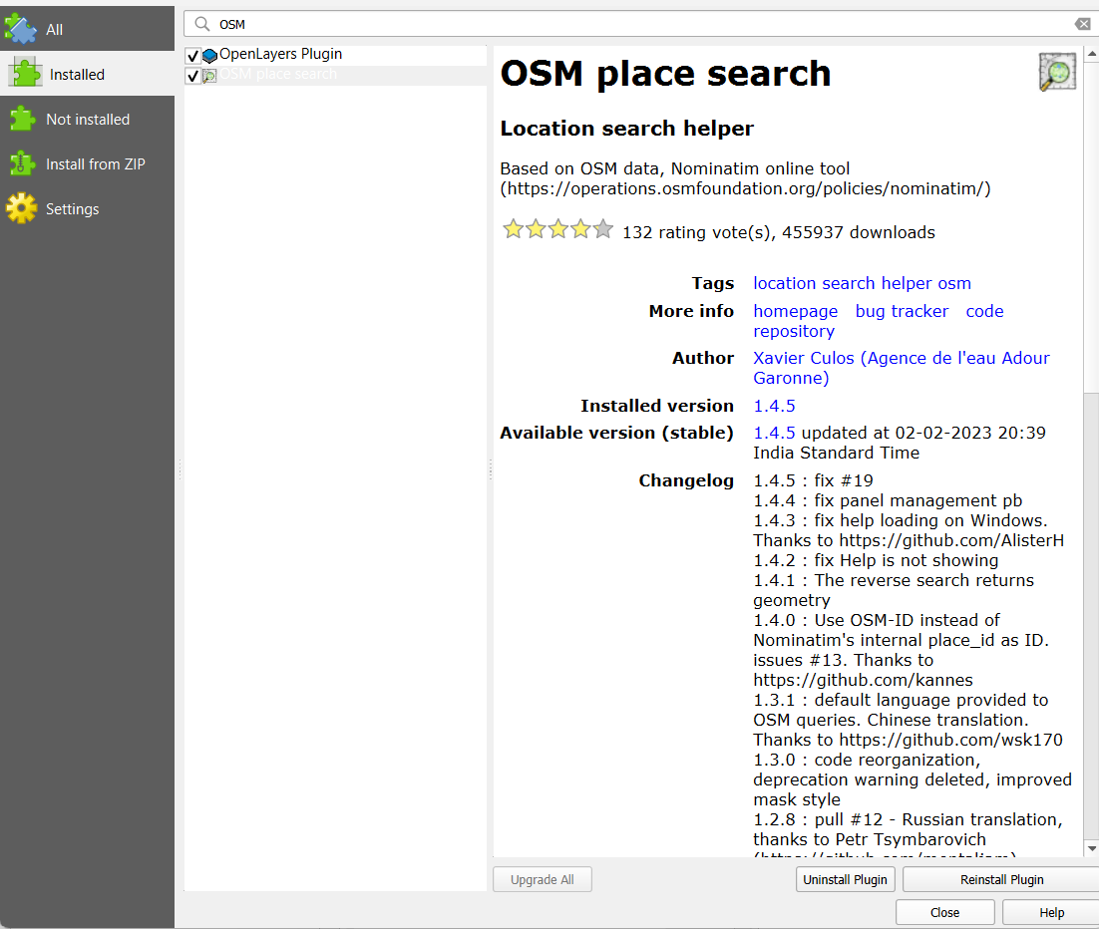➢ Open Layers Plugin AND OSM Place Search

➢ View → Panels → select OSM Place Search

➢ Go to Web → Open Layer Plugin and select Open Street Map (A World map will appear on screen.)

➢ In OSM Place search Pane → Enter Mumbai or any place name to search

➢ Double click on the desired place in OSM Place search Panel or Click and press

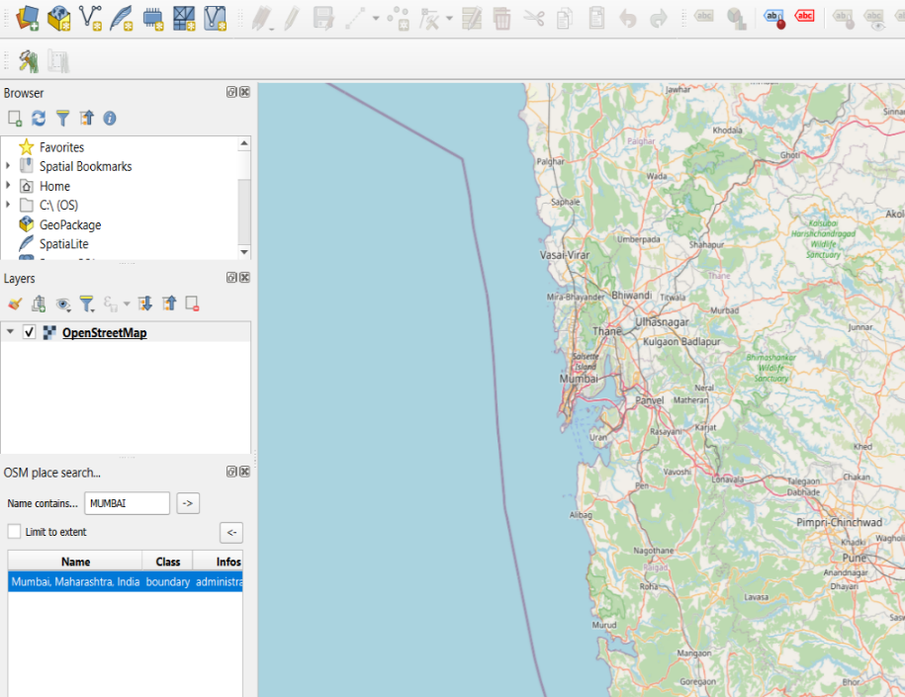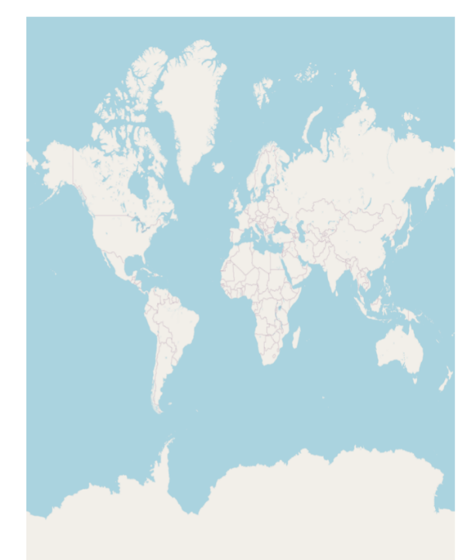

**PRACTICAL – 5**

**A] Working with Attributes**

➢ Start a new project.

➢ Go to Layer → Add Layer → Add Vector Layer

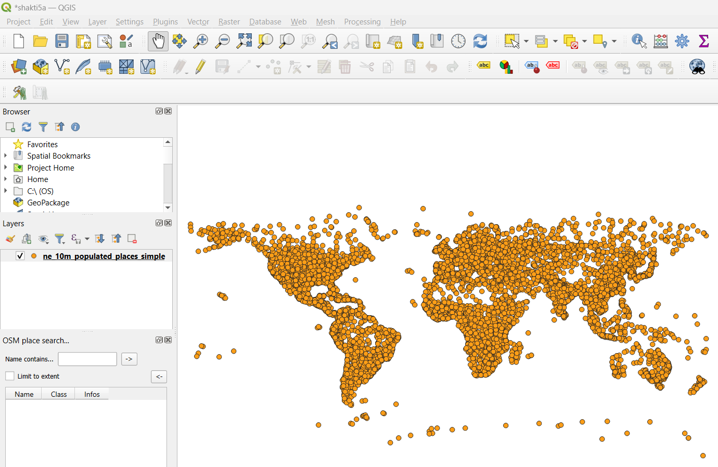➢ Select “\GIS_Workshop\Practicals\Practical_04\A\Data\ne_10m_populated_places_simple.zip”

➢ Right click on Layer in Layer Panel → Open Attribute Table.

➢ Click on the Select feature using expression button the window will appear.

➢ Enter pop_max>100 and pop_max<1000 and click Select Feature Button to get all the places with population between 100 and 10000

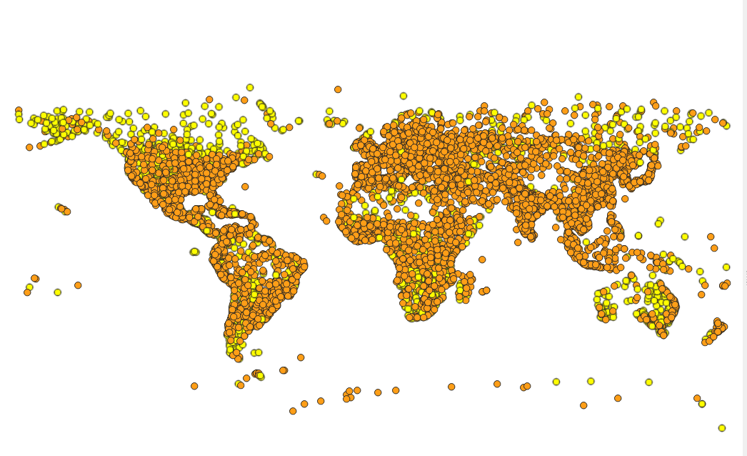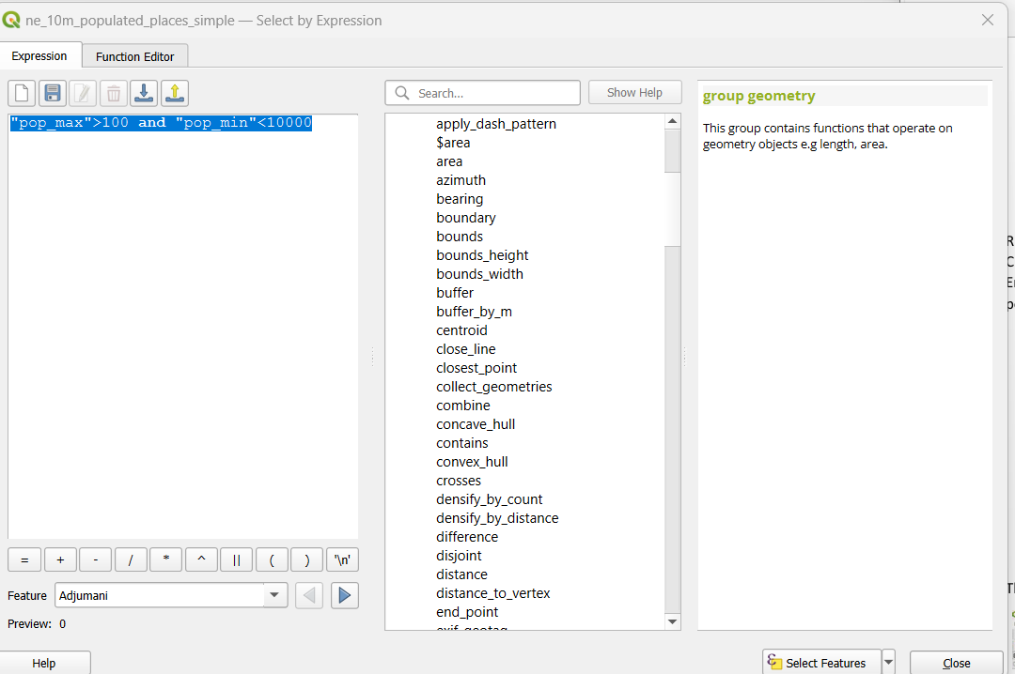

➢ The places matching the criteria will appear in different color.

➢ You can Perform different Queries in the following way

**B] Terrain Data and Hill Shade Analysis**

➢ Go to Layer → Add Raster Layer → select “10n060e_20101117_gmted_mea300.tif”, from Data folder

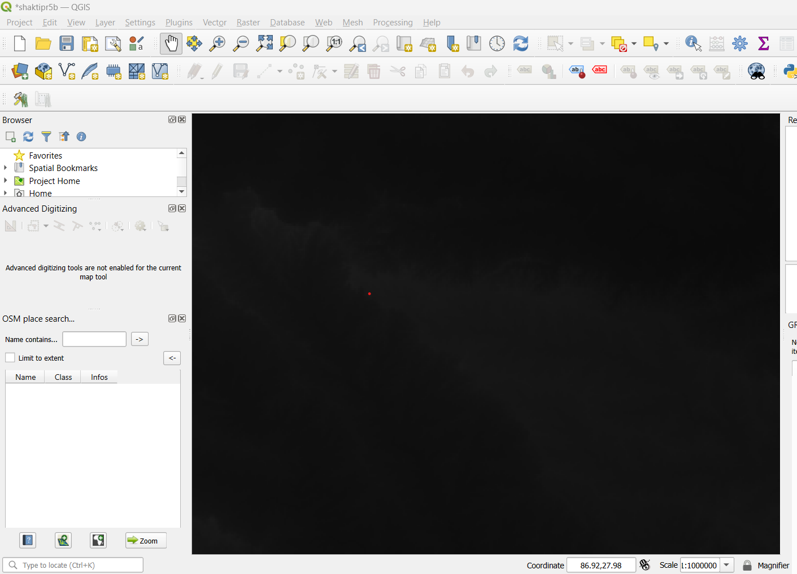

➢ Go to Raster → Extraction→ Clip Raster by Extent

➢ Set Clicking Extend to Using Canvas Extends

➢ Select the location and Save the Clipped raster file and then Click On RUN

➢ To derive counter lines from given raster.

➢ Go to Raster → Extraction→ Contour

➢ Set input layer to clipped, set interval to 100 and set Attribute name to ElEV 10. Select the file location, name it and save it then click on RUN 11. Label the Layer using ELEV Field and Set appropriate Symbol Line

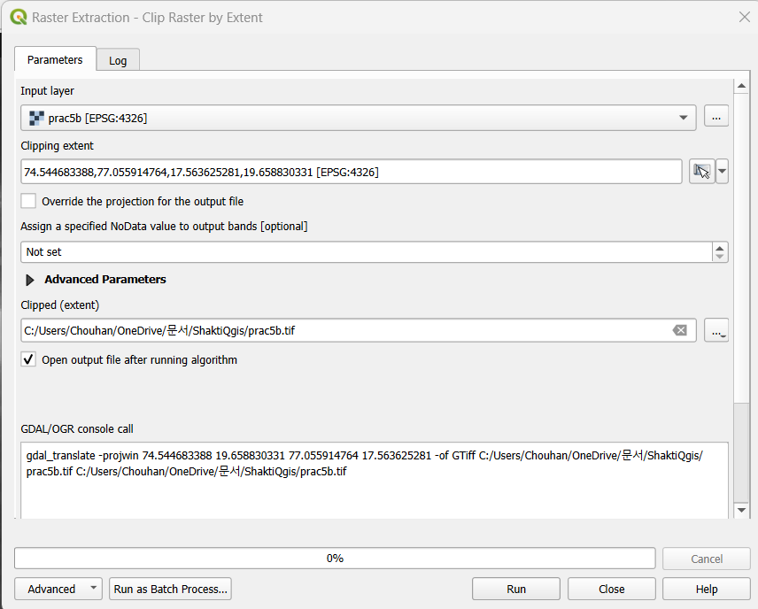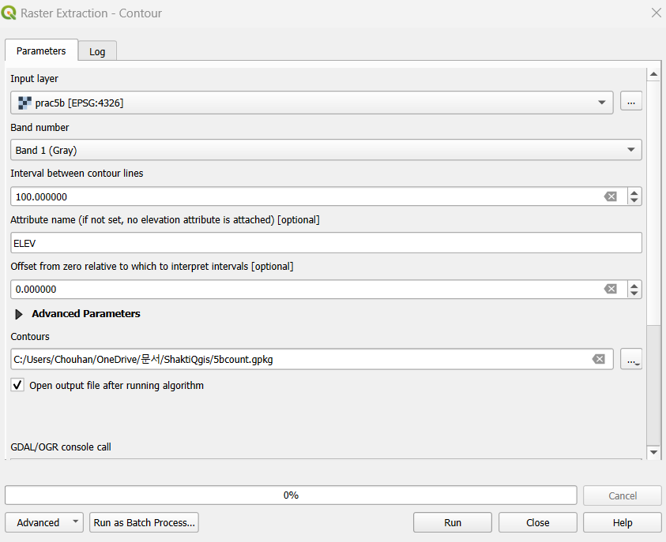

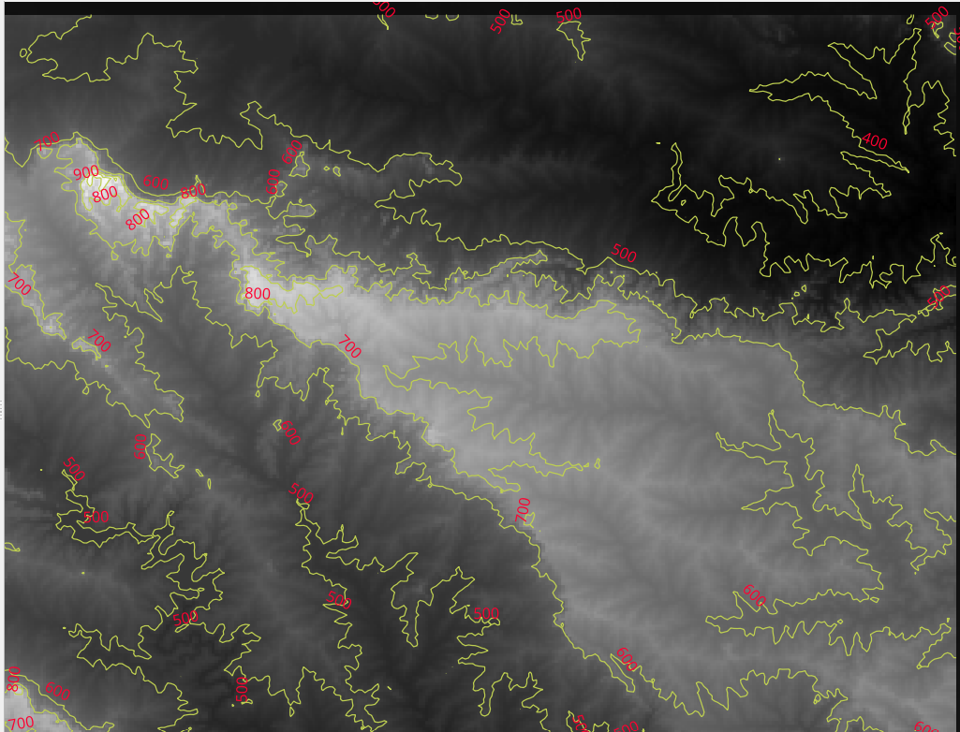Contor Layer will appear like this:

➢ In the Layer panel right click on Contour Raster Layer and select “Open Attribute table”.

➢ Arrange the table in descending order based on the value of “ELEV” column.

➢ Select First Row and Click on Zoom Map Button

➢ For Hill Shade surface analysis

➢ Go to Plugin → Install Georeferencer GADL.

➢ After successful installation of plugin Go to Raster → Analysis → Hill Shade

➢ Select the input raster layer, select file name and location for storing Hill Shade output file.

➢ Press Run and close it

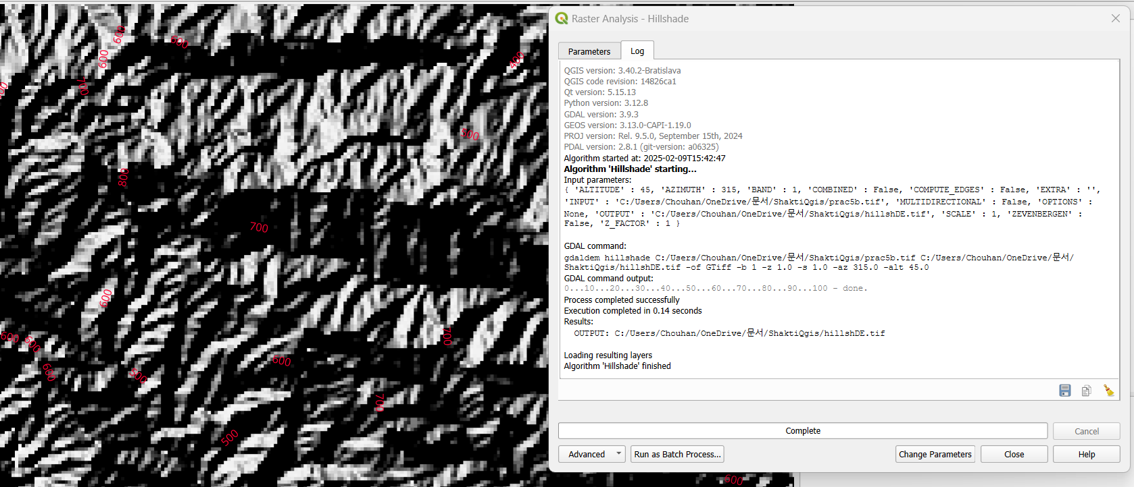

**PRACTICAL – 6**

**Working with Projections and WMS Data:**

➢ Start a new Project.

➢ Layer → Add Layer →Vector Layer

➢ Select “ne_10m_admin_0_countries.zip” Layer from data folder.

➢ Go to Layer → Save As

* Select format as ESRI Shape File
* Select folder location and file name
* 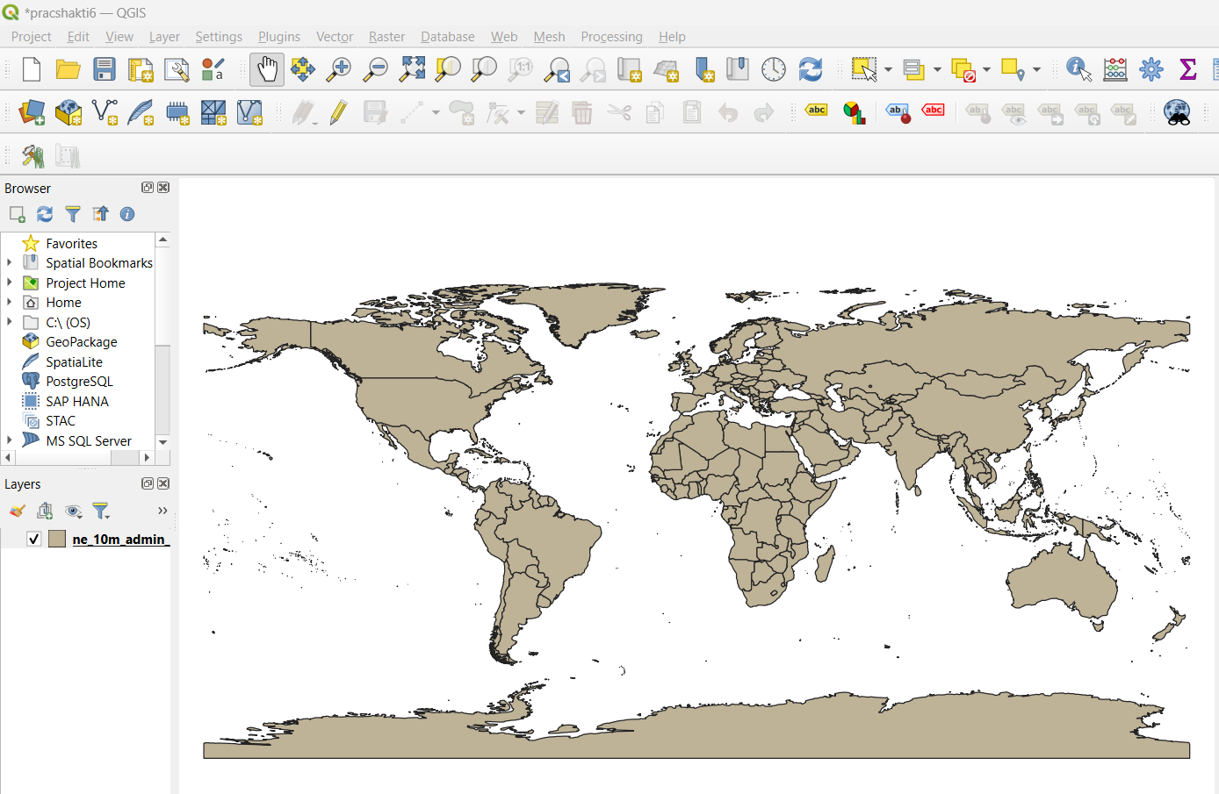Set CRS North_America_Albers_Equal_Area_Conic EPSG: 102008 and Press ok

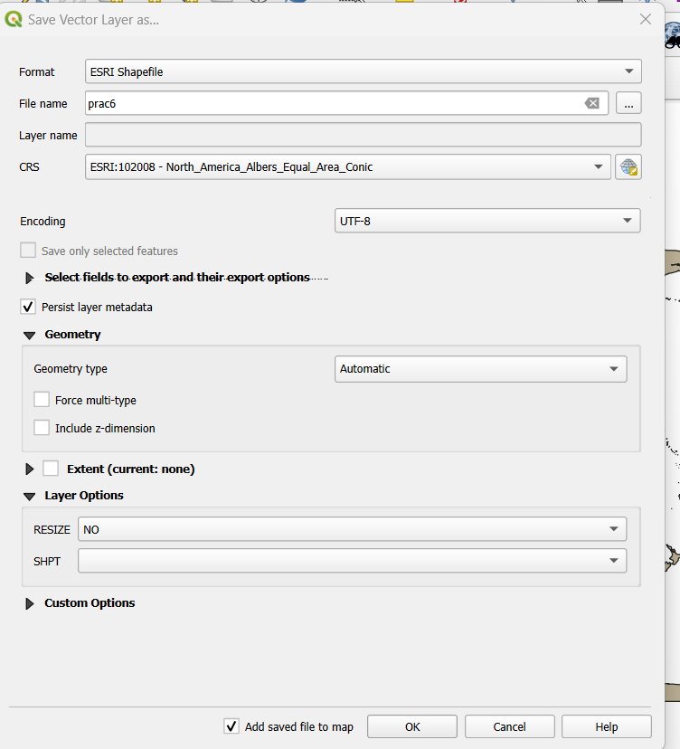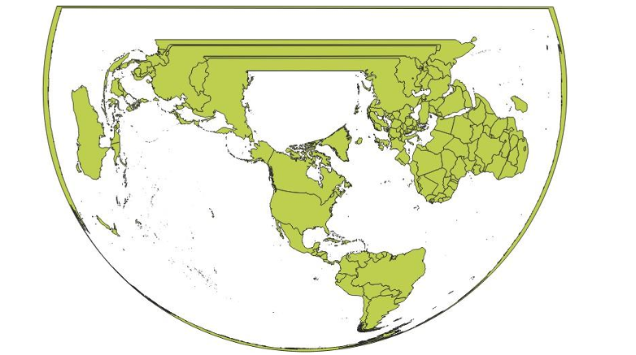

* Select Layer → Add Layer → Add Raster Layer → Select Mini Scale_(standard)_R17.tif from Location
* The Layer appears on a different location than the location where Great Britain is shown on Map.
* Project → Properties → CRS → select British National Grid EPSG 27700.

**Output:**

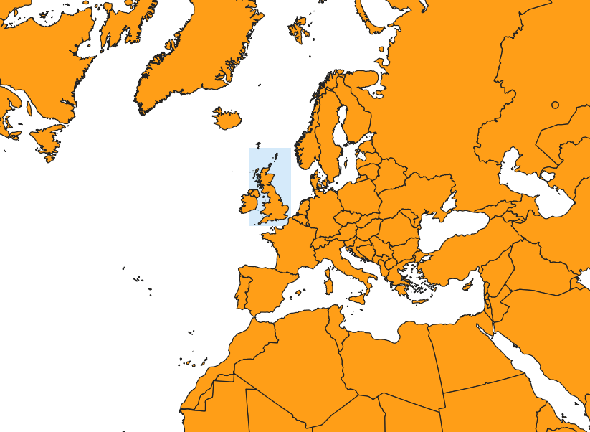

**PRACTICAL – 9**

**Advanced GIS Operations:**

**A] Nearest Neighbor Analysis**

1. Add vector layer and load (ne_10m_populated_places_simple.zip)

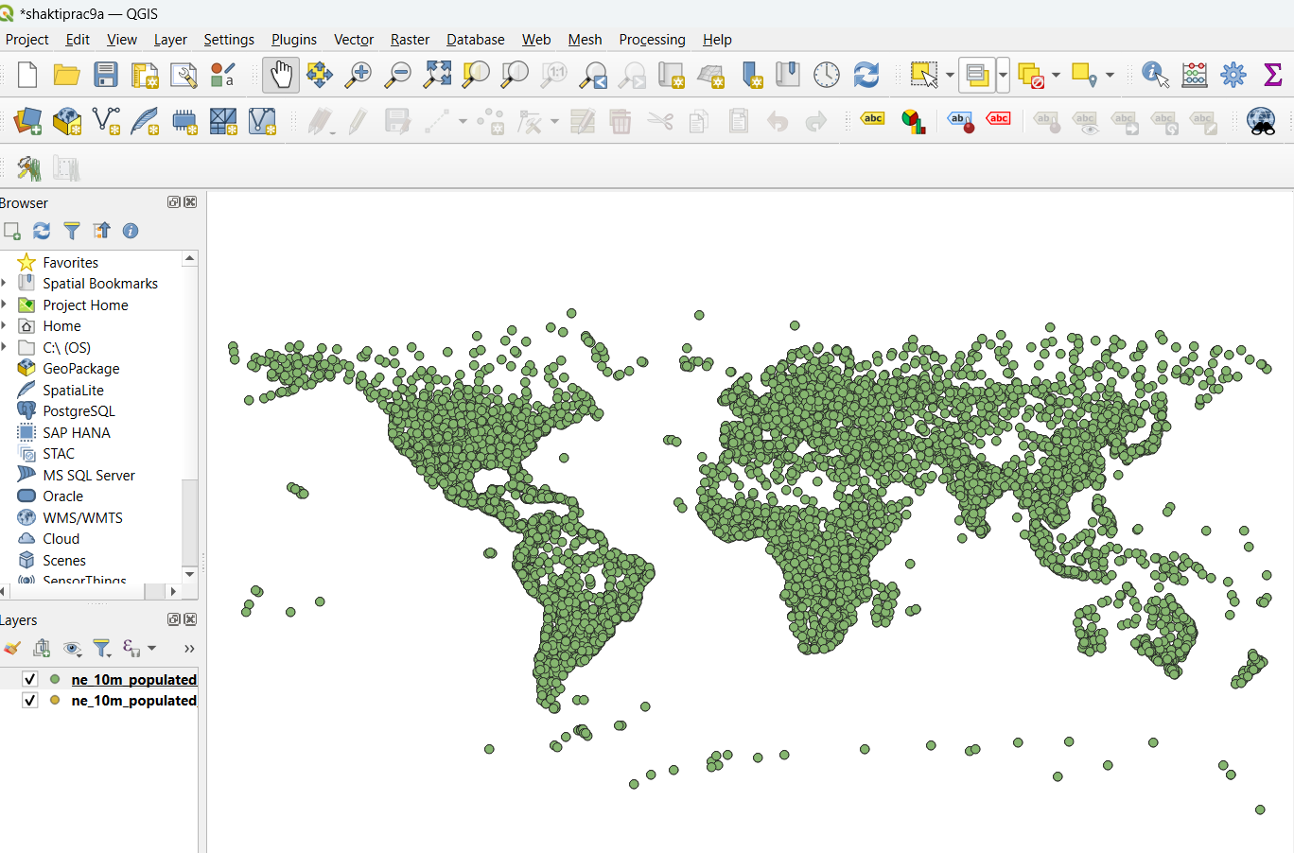

1. Go to Layer → add Layer → add Delimited Text Layer and load below file from data file. (earthquakes_2021_11_25_14_31_59_+0530.tsv)
2. Go to Processing -> Tool-Box -> Vector Geometry - > Remove Null Geometries
3. 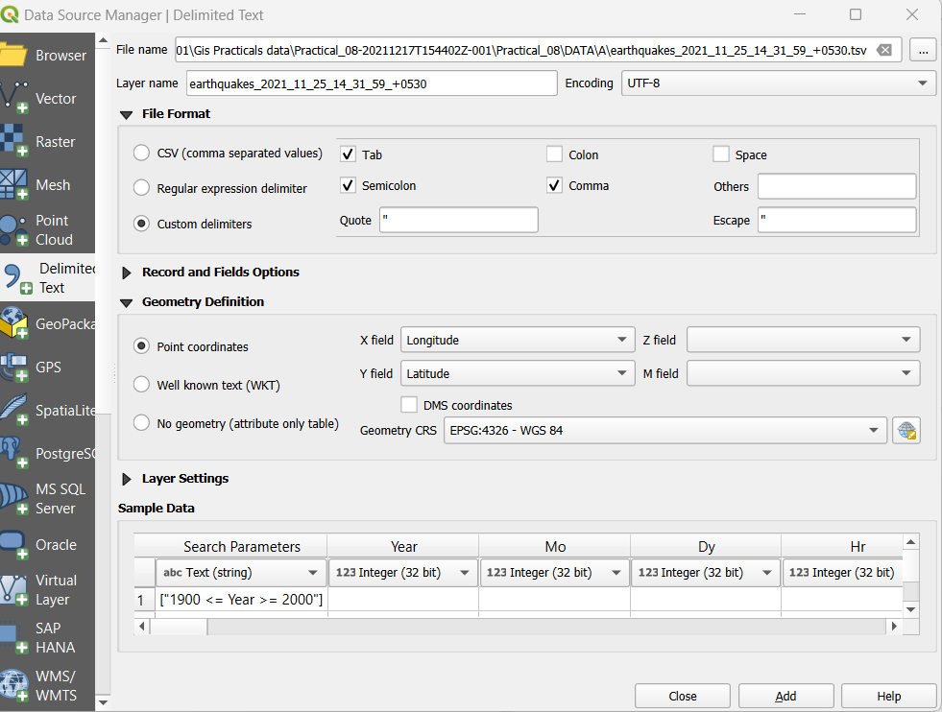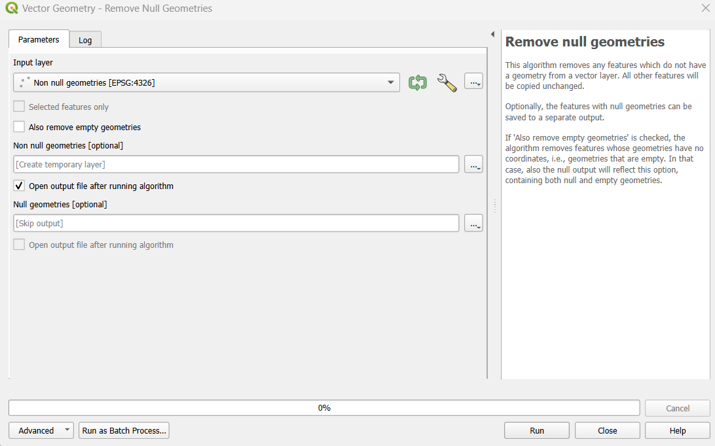Go to Processing -> ToolBox -> Vector Analysis - > Distance to Nearest hub (Line to hub)

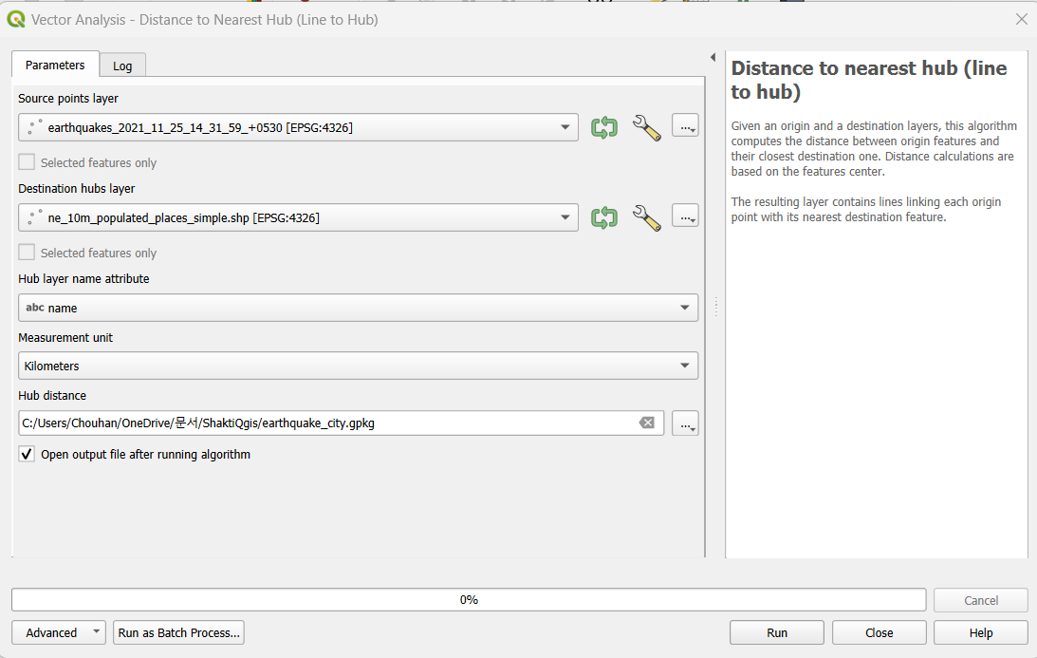

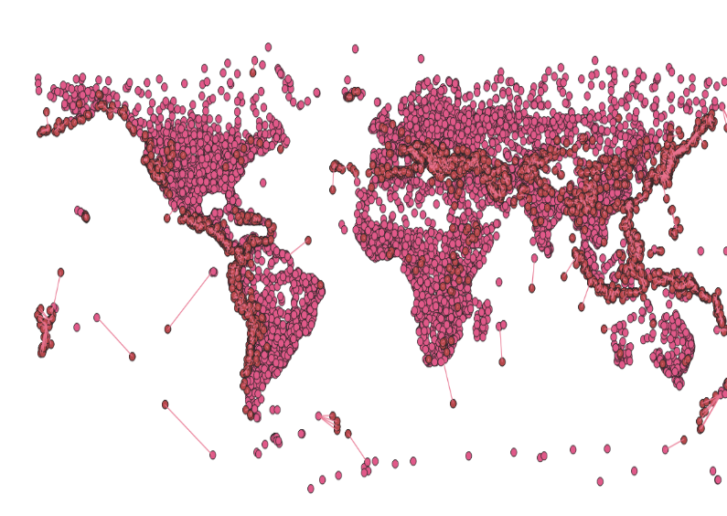

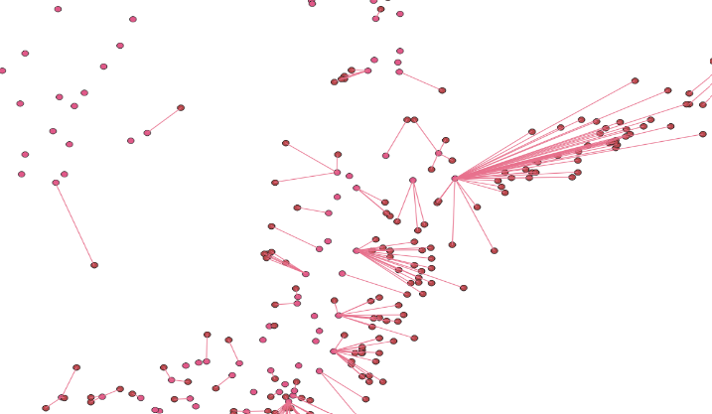

**B]** **Sampling Raster Data using Points or Polygons**

1. 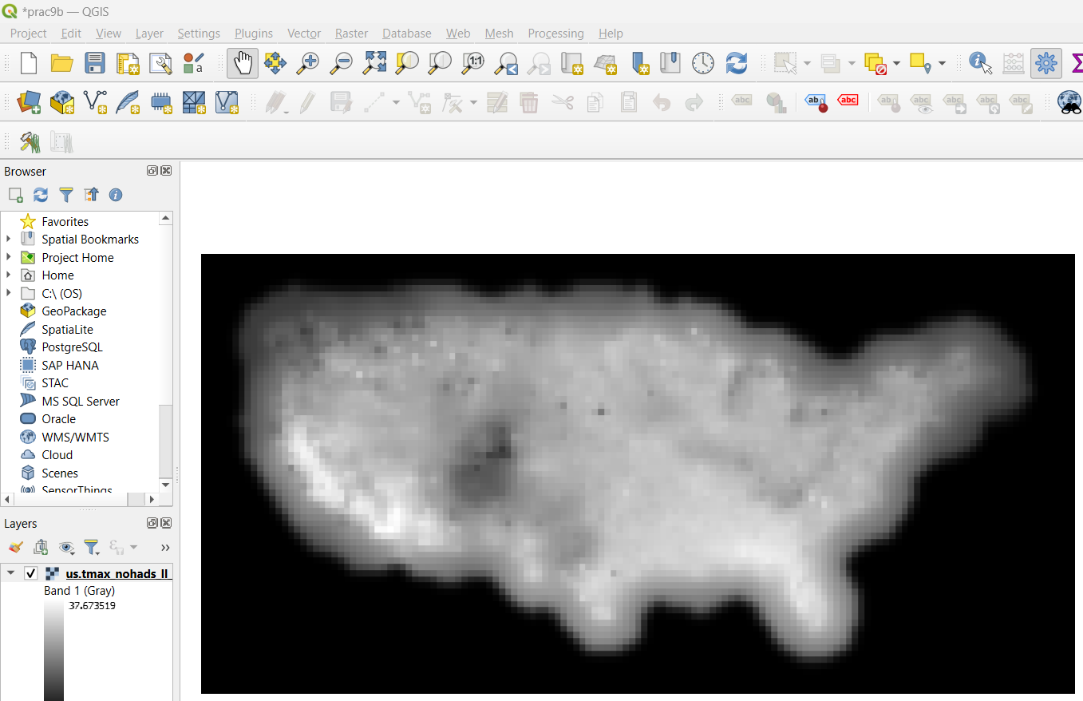Go to Layer → Add Raster Layer (us.tmax_nohads_ll _float.tif )
2. Go to Layer ‣Add Delimited Text Layer. (2013_Gaz_ua_national.zip )
3. Processing → toolbox → Raster Analysis → Sample Rasyer Values
4. Add raster layer and prefix in it and run it

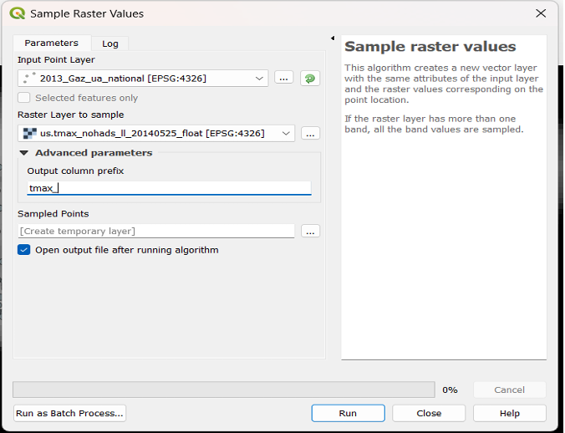

1. Use I button to See the value of tmax of Selected point
2. Then remove those or unselect the 2 layer for performing next prac
3. Go to Layer → Add Vector Layer (us_county.shp )
4. Processing → toolbox → Raster Analysis → Zonal Statistics
5. Select taster layer and put prefix in it also select MEAN option only
6. RUN it

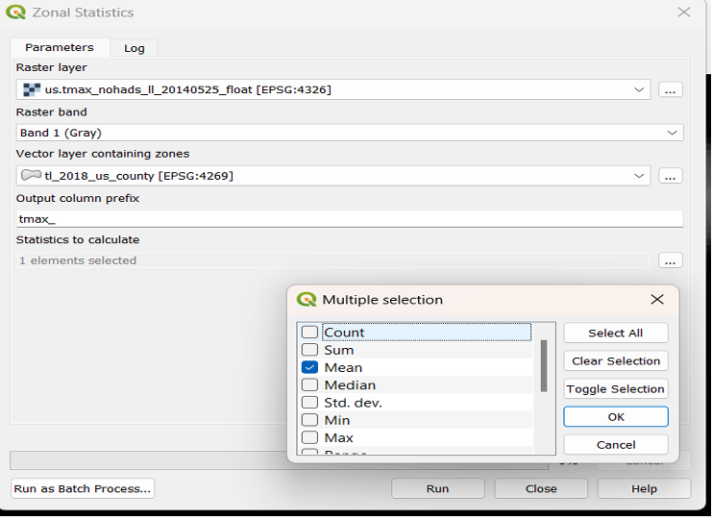

1. Use I button to select one field and the value of tmean value will come

* 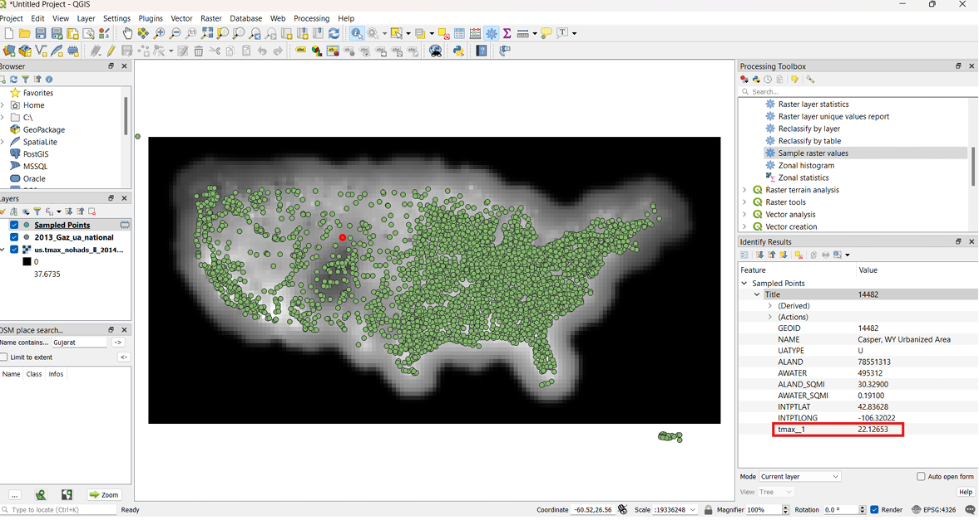Point Output:
* 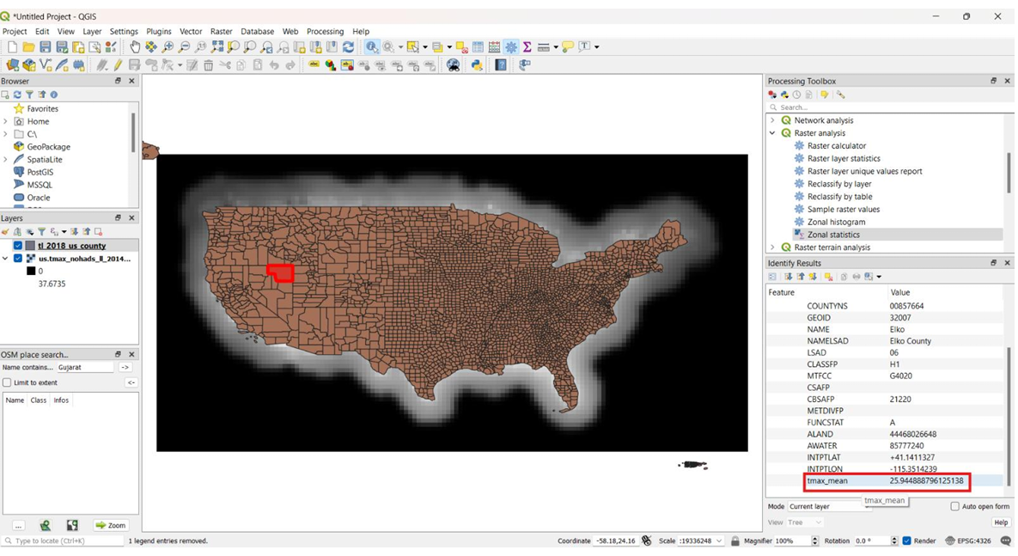Polygons output:

**C]** **Interpolating Point Data**

1. 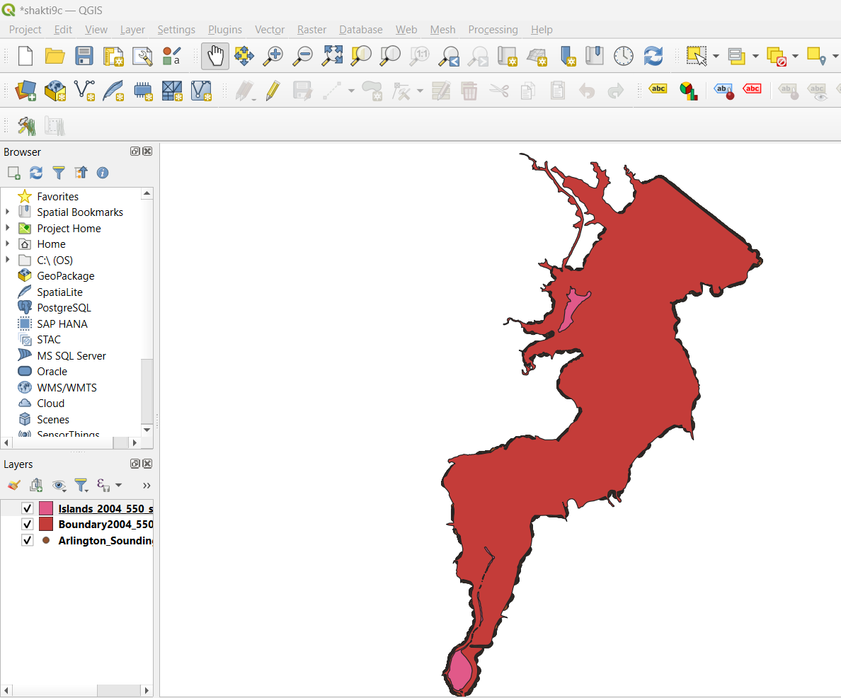Go to Layer → Add Vector Layer (Arlington_Soundings_2007_stpl83.shp , Boundary2004_550_stpl83.shp , Islands_2004_550_stpl83.shp)
2. 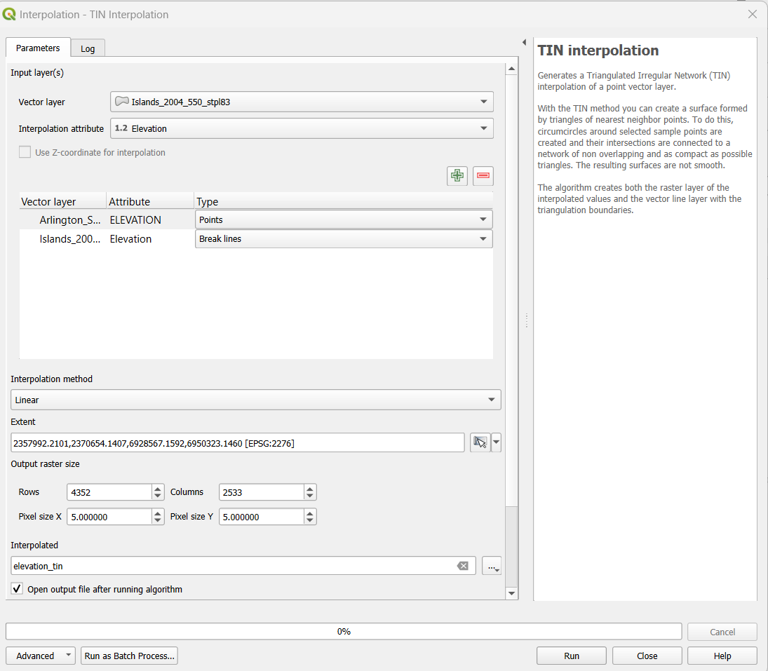Go to Processing ToolBox -> Interpolation -> TIN interpolation

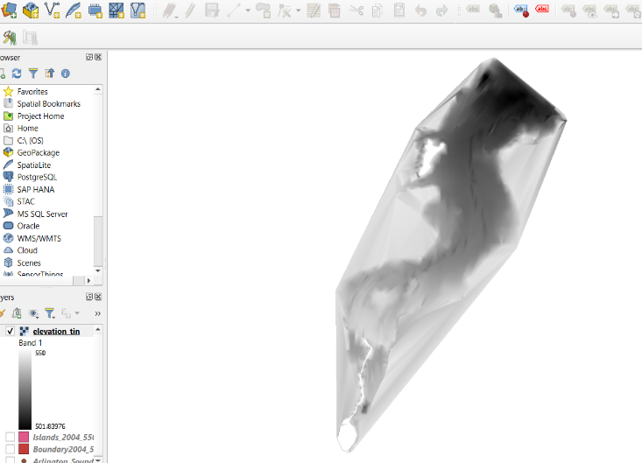

1. 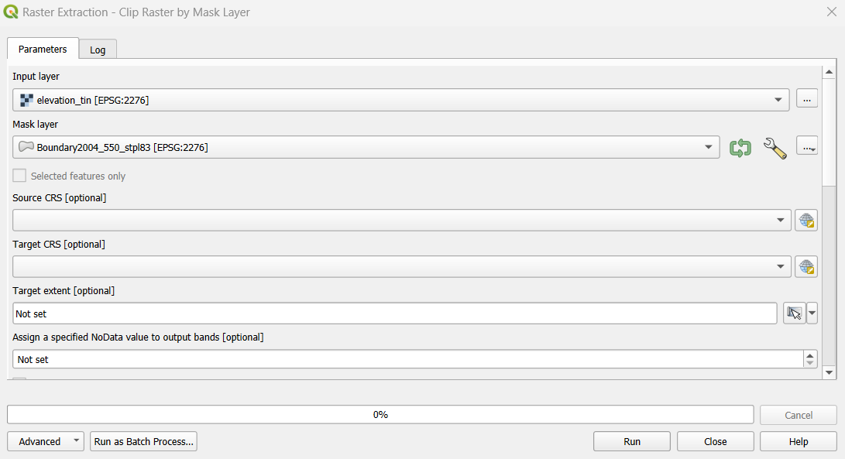Go to processing Tool-Box -> GDAL -> Raster extraction -> Clip raster by mask layer Create a clipped layer, after that change the color

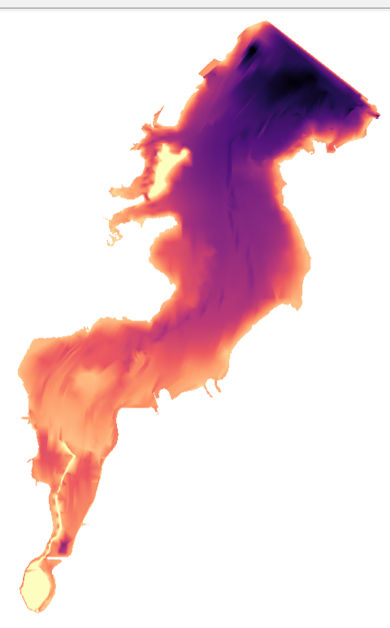

1. Now Go to Processing ToolBox -> GDAL -> Raster extraction -> Contour Then Add Label with ELEV and placement : curved

